**Anti-sway Control of Overhead Cranes**

# **1 Introduction**

## **1.1 Literature Study**

Gantry crane occupy a crucial role in several industries thanks to their capability to deliver all kinds of heavy loads in various locations such as shipping yards, steel mills, construction sites, waste storage facility, nuclear power stations, and other industrial complexes. Swaying of the payload is an undesirable phenomenon because it increases transfer time and risk of accident. The operations of conventional gantry cranes were controlled mostly by human operator who relies on self-skills and experience. Because of the high reliance on human operator, companies have funded research to automate crane control or assist the human operator in order to effectively reduce sway angle while on the other hand optimize transfer time despite the presence of unmodeled system dynamics and external disturbances.

There are three general ways for anti-sway control in the literature namely, time-optimal control, feedback control, and input shaping method. Since the late of twentieth century, there are many approaches to deal with crane systems. The earliest implementation was by optimal control without considering about hoisting motion [1]. In [2], bang-bang control was implemented in which the rope length was fixed. Sakawa [3] derived an optimal control law using five different sections of the load motion. In [4], gain scheduling control approach is proposed for anti-sway control of crane. The controller works satisfactory by addressing the nonlinearity of the model into several linear operating points. A time optimal control law using linearized model is investigated in [5]. Since the swing of payload depends on the acceleration of the trolley, minimizing both the operation time and the payload swing produces partially conflicting requirements. Hence, the controllers which suffer from lack of precise mathematical model may significantly lose robustness.

Feedback control is the most often used strategy in dealing with trolley positioning and cable sway errors. This type of control is aptly suited for a bridge or a trolley. However, when a feedback controller must minimize cable sway, the control task becomes more troublesome. Accurate sensing of the payload must be acquired, which is often costly or difficult. In [6], several state observers or disturbance observers were implemented to achieve the accurate mathematical model of the system. And in [7], an inclinator is introduced as an alternative to the costly vision sensor. However, the feedback control schemes are quite slow because the nature of the compensation is inherently reactive. For example, when feedback is utilized to control a cable sway, cable sway must present in the system first and observed before the controller can attempt to eliminate the undesired oscillations.

Another strategy introduced in [8] is to control the trolley in an anticipatory manner as opposed to reactive, by a predefined trajectory input such that the system will have zero or minimum sway angle. The basic idea of the profile is to accelerate the trolley until the load gets the minimum allowed angular displacement. Then continue moving at a constant speed until the load gets the maximum allowed angular displacement. Next accelerate again the trolley in order to get the point where the trolley and the load are travelling at the same speed so the angular displacement must be zero. Finally the profile suggests applying the reverse manoeuvre in order to stop the trolley and the load. This input shaping method, which does not require any feedback from the system, has been proven very effective in eliminating motion-induced oscillations. The input shaping method is much easier to implement than closed-loop control and has been used in indoor crane applications. However, due to the lack of feedback, input shaping techniques are not able to suppress disturbance-induced oscillations. Furthermore, this approach requires zero initial condition. Therefore, command shaping must be used in conjunction with feedback control if disturbance rejection characteristic is necessary.

In the past years, due to the difficulties and computational inefficiency in developing a precise mathematical model of the system, several soft computing techniques have been proposed. The advantage of these controllers is that they treat the system as a black box i.e. model-free controller such that requirement of an exact mathematical model is removed. In [9], evolutionary genetic algorithm is implemented in anti-sway control. Inspired by natural selection processes, the controller adapts and selects time-optimum control parameters each time the parameters in the system changes e.g. payload’s mass, hoist rope length, etc. In [10], fuzzy logic controller, which is tolerant to imprecise data, is applied for position control and sway-angle reduction. In [11], sliding mode controller (SMC) is implemented along with disturbance observer. The advantage of this method lies in the combination of the robustness of SMC with the noise and disturbance insensitivity characteristic of a disturbance observer. Other soft-computing method which is inspired by human brain, namely the artificial neural network has also been implemented to achieve satisfactory performance despite the unavailability of exact mathematical model and nonlinearity of the system.

This report is divided in six sections. Section 2 will be dedicated for system modeling. In Section 3, a few control strategies will be discussed. Section 4 will discuss testbed model design. In Section 5, simulation studies will be presented. Finally, Section 6 will include conclusions and future work.

# **2 SYSTEM TO BE CONTROLLED**

## **2.1 KINEMATICS & Dynamics**

In Fig. 1, the schematic diagram of gantry crane, the trolley with mass M and payload with mass m can be seen. The load is assumed to be a rigid body symmetric about its axial axis. The position of the trolley and load are denoted as ($X, Y$) and ($x_{m}, y_{m}$) respectively. By taking the sway angle $θ$ as positive in Fig. 1, we can derive:

|  |  |
| --- | --- |
| $$x_{m}=X+Lsinθ$$ $$y_{m}=-Lcosθ$$ | (1)  (2) |

$$x_{m}$$

$$y_{m}$$

$$X$$

$$M$$

$$θ$$

$$m$$

$$L$$

$$F_{x}$$

$$Y$$

Fig. 1. Diagram of gantry crane

For simplicity and model linearization, the following assumptions are made:

1. The trolley and payload are regarded as point masses.
2. Friction force which may exist in the trolley can be neglected.
3. The length of hoisting rope is time-invariant because operator does not normally move the trolley and hoist at the same time. Elongation of the rope due to tension force is also neglected.
4. The trolley and load move in a 2D plane because no actuator is available to counter the sway in the third axis.
5. Practically, the sway angle is small <10o. Therefore this observation is used as an assumption.

Kinetic energy $T$ and potential energy $V$ of the system can be represented as

|  |  |
| --- | --- |
| $$T=\frac{1}{2}M{\dot{X}}^{2}+\frac{1}{2}m\left( {\dot{x_{m}}}^{2}+{\dot{y_{m}}}^{2}\right)$$ $$V=mgy_{m}=-mgLcosθ$$ | (3)  (4) |

where g is the gravitational acceleration.

Then the Lagrangian function equation $L=T-V$ is obtained as

|  |  |
| --- | --- |
| $$L=\frac{1}{2}M{\dot{X}}^{2}+\frac{1}{2}m\left({\dot{x}}^{2}+\dot{L^{2}}+L^{2}\dot{θ^{2}}+2\dot{x}\dot{L}sinθ+2\dot{x}L\dot{θ}cosθ\right)+mgLcosθ$$ | (5) |

By the Lagrange multiplier’s general equation

|  |  |
| --- | --- |
| $$\frac{d}{dt}\left(\frac{∂L}{∂\dot{q}}\right)-\frac{∂L}{∂q}=Q$$ | (6) |

The equations of motion related with the generalized coordinates $q=[X, θ]$ can be derived as

|  |  |
| --- | --- |
| $$\left(M+m\right)\ddot{X}+mL\left(\ddot{θ}cosθ-\dot{θ^{2}}sinθ\right)+2m\dot{L}\dot{θ}cosθ+m\ddot{L}sinθ=F_{x}$$ $$\ddot{X}cosθ+L\ddot{θ}+2\dot{L}\dot{θ}+gsinθ=0$$ | (7)  (8) |

By the previous assumptions, we have

$$sinθ≈θ, cosθ≈1, \dot{θ^{2}}≈0, \dot{L}=\ddot{L}≈0$$

Therefore equation the equations of motion can be simplified as

|  |  |
| --- | --- |
| $$\left(M+m\right)\ddot{X}+mL\ddot{θ}=F_{x}$$ $$\ddot{X}+L\ddot{θ}+gθ=0$$ | (9)  (10) |

# **3 Control Strategies**

## **3.1 OPEN-loop INput Shaping Method**

From (10), we can obtain the transfer function of $θ(s)/\ddot{X}\left(s\right)$ as a second order equation.

|  |  |
| --- | --- |
| $$\frac{θ\left(s\right)}{\ddot{X}\left(s\right)}=\frac{1}{L(s^{2}+ω^{2})}$$ | (11) |

in which $ω=\sqrt{g/L}$.

If we apply constant acceleration impulse from t0 to t1, then from the inverse Laplace transfer function of (11) at $t> t_{1}$ we obtain the sway angle

|  |  |
| --- | --- |
| $$θ\left(t\right)=\frac{a}{g}\{cosω\left(t-t_{1}\right)-cosω\left(t-t_{0}\right)\}$$ | (12) |

Similarly, if we then apply the same constant acceleration impulse from t2 to t3, then at $t>t_{3}$ we will have the resultant sway angle

|  |  |
| --- | --- |
| $$θ\left(t\right)=\frac{a}{g}\{cosω\left(t-t_{1}\right)-cosω\left(t-t_{0}\right)+ cosω\left(t-t_{3}\right)-cosω\left(t-t_{2}\right)\}$$ | (13) |

Therefore if we carefully select the pair of these two pulses satisfying $t_{3}=t_{1}+T/2$ and ${ t}_{2}=t_{0}+T/2$, then we will able to obtain resultant sway angle $θ\left(t\right)=0$.

By these pulses pair, maximum velocity can be achieved after a few pulses pair of maximum acceleration while keeping the sway angle bounded. Letting $θ(t_{0})=0$ and on-off of the impulses as equal width $t_{1}-t_{0}=t_{2}-t_{1}=t_{3}-t_{2}=T/4$, the minimum and maximum sway angle at $t_{0}≤t≤t_{3}$ happen at t1 and t2 respectively. Therefore, we can set maximum acceleration with respect to maximum allowable sway-angle.

|  |  |
| --- | --- |
|  | (14) |

After each pulses pair, the velocity is increased as

|  |  |
| --- | --- |
| $$v\left(t_{3}\right)=\frac{aT}{2}+v\left(t_{0}\right)$$ | (15) |

For optimal time transfer, n amount of pulses pair are actuated successively with $a=a_{max}$ followed an acceleration pair $a≤a_{max}$ to reach maximum velocity ${ v}_{max}$. After travelling at ${ v}_{max}$ for some time, deceleration can be achieved by reverse manner. The amount of pulses and parameters can be pre-calculated easily for travelling distance $D$ by the area under velocity profile. This method is adapted from [12].

Apart from this pre-calculated trajectory input shaping, there exist an online input shaping function block which shapes the velocity profile $v_{ref}$ accordingly into $v_{ref}'$. This trajectory modifier is also well known as Zero Vibration input shaper. Figure 2 shows zero-vibration input shaper filter with gain values A1 and A2 given in [13].

$$A_{1}$$

$$A_{2}$$

Transport delay

$$v_{ref}$$

$$v_{ref}'$$

+

+



Fig. 2. ZV-filter module

+

+

## **3.2 CLOSED-LOOp anti-sway damping factor with sway-angle estimator**

## 

In Fig. 3, an anti-sway damping factor is incorporated to velocity output of a position controller. Then the reference velocity will be taken as an input to a speed controller which outputs $F_{x}$ to the system. In order to develop the anti-sway damping factor, we observe the relation of $\dot{X}$ with $\dot{x_{m}}$.

With the small angle assumption, equation (1) can be rewritten as

|  |  |
| --- | --- |
| $$θ=(x_{m}-X)/L$$ | (16) |

Differentiating (16), the acceleration of sway angle is

--

+

Position controller

$$-\frac{\frac{1}{L}}{s^{2}+\frac{g}{L}}$$

Crane Plant

Speed Controller

$$gK$$

$$v_{ref}$$

$$v$$

$$F_{x}$$

$$\ddot{X}$$

$$θ_{est}$$

$$v_{ref}'$$

+

+

$$e$$

Trajectory generator

$$X$$

$$X_{ref}$$

+

-

Fig. 3. Closed-loop anti-sway damping factor control scheme

|  |  |
| --- | --- |
| $$\ddot{θ}=(\ddot{x_{m}}-\ddot{X})/L$$ | (17) |

By (10),(16) and (17), we can obtain the relation between $X$ and $x_{m}$.

|  |  |
| --- | --- |
| $$\ddot{x_{m}}+\frac{g}{L}x_{m}=\frac{g}{L}X$$ | (18) |

Or in velocity terms

|  |  |
| --- | --- |
| $$v_{ref}^{'}=\frac{L}{g}\ddot{v_{m}}+v_{m}$$ | (19) |

Where $v_{ref}'$ denotes the speed reference of the trolley. Equation (19) is a second order transfer function without any damping. Hence, we introduce a damping term to suppress the sway of the payload. The $v_{ref}'$ can be modified as

|  |  |
| --- | --- |
| $$v_{ref}^{'}=v_{ref}-K\dot{v_{m}}$$ | (20) |

Therefore, combining (19) and (20) becomes

|  |  |
| --- | --- |
| $$\frac{L}{g}\ddot{v_{m}}+K\dot{v_{m}}+v_{m}=v_{ref}$$ | (21) |

From (21), the coefficient K can be defined as

|  |  |
| --- | --- |
| $$K=\frac{2ζ}{ω_{n}}$$ | (22) |

in which $ζ$ is the damping ratio, and $ω_{n}$ = $\sqrt{g/L}$. Substituting (17) to (10), we get $\dot{v_{m}}=-gθ$ and the speed reference for the trolley becomes

|  |  |
| --- | --- |
| $$v_{ref}^{'}=v_{ref}+Kgθ$$ | (23) |

From (10), the value of $θ$ can be estimated with trolley’s acceleration sensor and the transfer function

|  |  |
| --- | --- |
| $$\frac{θ\left(s\right)}{\ddot{X}\left(s\right)}=\frac{-1}{L(s^{2}+\frac{g}{L})}$$ | (24) |

This method is adapted from [7].

+

$$X$$

$$X_{ref}$$

Trajectory generator

$$e$$

Payload position estimator

--

+

Position controller

$$-\frac{\frac{1}{L}}{s^{2}+\frac{g}{L}}$$

Crane Plant

Speed Controller

$$gK$$

$$v_{ref}$$

$$F_{x}$$

$$\ddot{X}$$

$$v_{ref}'$$

$$x_{m}$$

+

$$v$$

Fig. 4. Closed-loop anti-sway damping factor with payload position feedback

## **3.3 CLOSED-LOOp anti-sway damping factor with payload position As feedback**

The control scheme in 3.2 controls both trolley’s position and sway angle in order to indirectly control the position of payload. If we modify the control scheme such that we can directly control payload position to track the generated trajectory, then we can have a more robust control as payload’s position is the main interest. In fact, this can be intuitively done by changing the feedback of position control in Fig. 3 from previously trolley’s position into load’s position. The load position can be estimated by equation (1) provided trolley’s position $X$ and sway angle $θ$ as shown in Fig. 4. The advantage of this method is that, smooth transfer of the payload can be guaranteed. The sway-damping term is still important as it defines the distance of trolley to payload and therefore the stability of the system.

The stability proof of this control scheme is not yet derived and left for future study.

# **4 TestBed Design**

## **4.1 Mechanical Design**

In order to verify control schemes as well as for future study, a scaled down model of crane is designed for testbed. The proposed design consist of two DOFs namely trolley’s speed and cable hoisting. The proposed design as shown in Fig. 5 is very simple consisting of aluminum frame as support, belt linear guide, one motor for trolley’s transverse motion, and another motor as a hoisting mechanism. A few parts which were not standard parts have to be designed with specific dimensions using Solidworks. The standard parts are purchased from Misumi supplier. Table 1 shows the parameters of the actual crane and model crane.

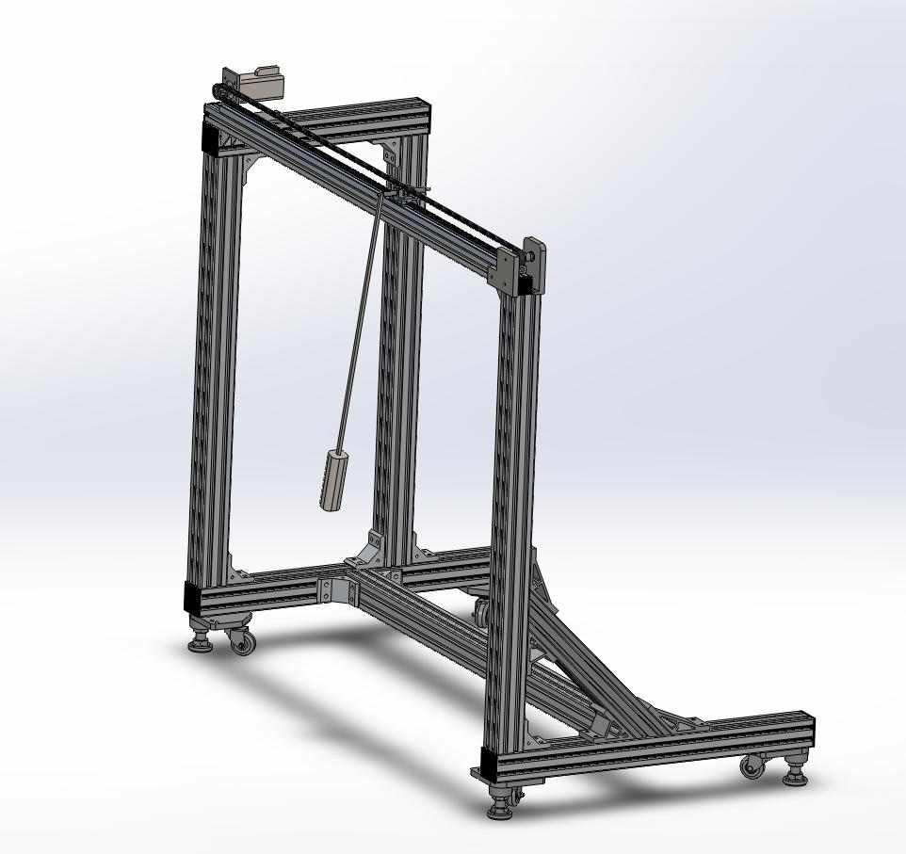

|  |  |  |
| --- | --- | --- |
| TABLE 1 | | |
| Parameters | Actual Crane | Model Crane |
| Trolley mass M | 26 ton | 1.2 kg |
| Payload mass m | 67.3 ton | 1 kg |
| Length of hoist rope L | 40 m | 0.6 m |
| Rated speed of trolley | 3 m/s | 0.5 m/s |
| Rated acceleration time | 0.5 m/s2 | 0.1 m/s2 |
| Rated power of trolley motor | 110 kW | 232 W |
| Gravitational acceleration g | 9.81 m/s2 | 9.81 m/s2 |

Fig. 5. Model crane design

## **4.2 Sway-Angle Sensing method**

One drawback of the model design is that, because wire string is used to suspend the load instead of a rod, sway angle verification cannot be easily measured (encoders at the trolley cannot be implemented). As mentioned before, the costly vision-based sensors are often used on real cranes. But for experimental purpose, a low cost method is proposed by utilizing a high resolution ultrasonic sensor.

From Fig. 6, as $θ$ is a one-to-one function to $d$ and assumed to be small, we can obtain

|  |  |
| --- | --- |
| $$θ=\cos^{-1}{(\frac{H}{L+d})}$$ | (25) |

in which $L$ denotes string + load length and $d$ denotes distance from ultrasonic sensor. The sensor chosen must have the angular range equal or larger than the boundary of $θ$. In addition, the ultrasonic distance sensor must possess high resolution (1mm) and sufficient feedback frequency for real time implementation.

Fig. 6. Proposed sway-angle sensing method using ultrasonic distance sensor

$$X$$

$$θ$$

$$L$$

$$d$$

$$H$$

Ultrasonic

Sensor

# **5 simulation studies**

## **5.1 INPUT SHAPING RESULTS**

In order to verify the input shaping method presented in Section 3.1, a load transfer task from position 0m to 120m was assigned to the open-loop system and simulated with parameters of actual crane in Table 1. The simulation results are presented in Fig. 7. Fig. 7(a)(b) shows the pre-calculated acceleration-deceleration impulses pairs fed to the system and the resulting velocity profile respectively. The input is modified into two different acceleration values to reach ${ v}_{max}=3 m/s$ from zero initial condition for time optimization. As shown in Fig. 8(a), both payload and trolley experienced smooth trajectory throughout the transfer process. The induced sway angle, as shown in Fig. 8(b), is minimal and bounded by designer’s preference.

Despite the satisfactory results of input shaping, external disturbances are neglected and hence the method can only be implemented in less disturbance environment, e.g. indoor cranes.

## 

(b)

(a)

Fig. 7. Simulation results of input shaping method. (a) trolley’s acceleration profile, (b) trolley’s velocity profile



(b)

(a)

## 

Fig. 8. Simulation results of input shaping method. (a) position of payload and trolley, (b) sway angle

## **5.2 closed-loop anti-sway feedback results**

A realistic trajectory which satisfies crane’s dynamic constraints is assigned to closed loop system introduced in Section 3.2. Conventional proportional-derivative (PD) controllers are assigned to control position and speed as shown in Fig. 3. The trajectory generator drives the trolley from position 0m to 120m with simulation parameters given in Table 1. External disturbance such as wind gust is included into the simulation to test the effectiveness of the control scheme.

As seen in Fig. 9(a), the trolley follows the desired trajectory accurately. However, the payload oscillates at the finish point without being damped (except when frictional disturbance is present at hoist pivot). On the other hand, when the anti-sway velocity term is included, the payload’s sway will converge into stationary as shown in Fig. 9(b). The damped motion can be modified for faster settling time at the cost of bigger overshoot at endpoint by manipulating K value in Fig. 3. Comparison of the sway angle between both scenarios is shown in Fig. 9(c). The sway angle with anti-sway term converges faster to zero despite the presence of wind gust.



(c)

(a)



(b)

Fig. 9. Simulation results of closed-loop anti-sway feedback method. (a) position profiles without anti-sway, (b) position profiles with anti-sway, (c) sway-angle comparison

## **5.3 CLOSED-LOOp anti-sway damping factor with payload position feedback Results**

The proposed control scheme in 3.3 is tested under the same tracking task which is to deliver load from position 0m to 120m. The parameters of the real crane in Table 1 is used in the simulation. Two scenarios are shown, one with wind absent and the other with wind presence.

It is proven in both scenarios in Fig. 10(a) and (b) that the payload is able to track the reference trajectory perfectly. In Fig. 10(a) in order to compensate for the sway-angle, the trolley must oscillate around the trajectory especially in the initial and endpoint of the trajectory. While in Fig. 10(b), the trolley keeps swinging to compensate both motion-induced sway and wind gust. Sway-angles for both scenarios are shown in Fig. 11. It is desired for the trolley to track reference trajectory very accurately because the payload does not have the overshoot problem as in Section 5.2 and the payload moves in a predicted manner such that safety can be ensured. It is interesting to note that the profile when wind is absent is very similar to input shaping method results.

One concern is however, the trolley may oscillate back and front in high speeds that exceeds the motor constraints. Therefore, to keep this speed in allowable boundary, the trajectory speed must be decreased. Because of this, one has to select the optimum trajectory speed such that trolley speed is bounded in realistic values as well as minimum travel time. Owing to this reason, the presented method may not achieve optimum transfer time as compared to other methods, but the time required in Fig. 9 of 63s are acceptable. The speeds of the trolley in both scenarios are presented in Fig.12.



Fig. 10. Simulation results of closed-loop anti-sway with payload’s position feedback. (a) without wind, (b) with wind

# 

Fig. 11. Sway-angle comparison

Fig. 12. Trolley’s velocity comparison

# **6 conclusions and future works**

## **6.1 conclusions**

Various control schemes with their advantages and disadvantages have been discussed in literature study. Based on the analysis of input shaping method and feedback control method, we performed payload transfer and sway suppression task. Results show that input shaping method works satisfactorily in indoor environment and feedback control method works satisfactorily in windy condition. A novel feedback control is built by intuition and tested in similar simulation conditions. Results show that the control method is able to guarantee payload’s position despite wind’s presence provided the trolley’s velocity constraints are satisfied. In addition, a crane model with its sway angle sensing method is also proposed for future study.

## **6.2 future works**

Some possible future works include:

1. More uncertain factors, time varying variables or unknown values that mimic real-time application must be considered in future controller design. For example, future scenario can deal with unknown payload’s mass, time dependent hoist length, and presence of friction.
2. State observers must be developed for real-time applications because of sensor inaccuracy. Furthermore, method dealing with computational delay can be implemented.
3. Model-free controllers may be developed because of their advantage over the nonlinearity of the model and uncertainty of the crane working environment.
4. Finally, an integration of anti-sway system with heave compensation can be discussed for the realization of offshore cranes.

**references**

[1] G. Manson, 'Time-optimal control of an overhead crane model', Optimal Control Applications and Methods, vol. 3, no. 2, pp. 115-120, 1982.

[2] T. Mita and T. Kanai, 'Optimal Control of the Crane System Using the Maximum Speed of the Trolley', Transactions of the Society of Instrument and Control Engineers, vol. 15, no. 6, pp. 833-838, 1979.

[3] Y. Sakawa, Y. Shindo, Optimal control of container cranes, Automatica, Volume 18, Issue 3, May 1982, Pages 257-266, ISSN 0005-1098

[4] K. Zavari, G. Pipeleers and J. Swevers, 'Gain-Scheduled Controller Design: Illustration on an Overhead Crane', IEEE Transactions on Industrial Electronics, vol. 61, no. 7, pp. 3713-3718, 2014.

[5] J. Auernig and H. Troger, 'Time optimal control of overhead cranes with hoisting of the load', Automatica, vol. 23, no. 4, pp. 437-447, 1987.

[6] K. Sato, K. Ohishi and T. Miyazaki, 'Anti-Sway Crane Control Considering Wind Disturbance and Container Mass', Electr Eng Jpn, vol. 193, no. 1, pp. 21-32, 2015.

[7] Yong-Seok Kim; Han-Suk Seo; Seung-Ki Sul, "A new anti-sway control scheme for trolley crane system," Industry Applications Conference, 2001. Thirty-Sixth IAS Annual Meeting. Conference Record of the 2001 IEEE , vol.1, no., pp.548,552 vol.1, Sept. 30 2001-Oct. 4 2001

[8] N. Singer and W. Seering, 'Preshaping Command Inputs to Reduce System Vibration', J. Dyn. Sys., Meas., Control, vol. 112, no. 1, p. 76, 1990.

[9] J. Smoczek and J. Szpytko, 'Evolutionary algorithm-based design of a fuzzy TBF predictive model and TSK fuzzy anti-sway crane control system', Engineering Applications of Artificial Intelligence, vol. 28, pp. 190-200, 2014.

[10] Assa, A.; Raie, A.A.; Kashani, A.A.; Gorji, S.; Naraghi, M., "A four step design procedure for an improved fuzzy crane control," Autonomous Robots and Agents, 2009. ICARA 2009. 4th International Conference on , vol., no., pp.133,137, 10-12 Feb. 2009

[11] Maneeratanaporn, J.; Murakami, T., "Anti-sway sliding-mode with trolley disturbance observer for overhead crane system," Advanced Motion Control (AMC), 2012 12th IEEE International Workshop on , vol., no., pp.1,6, 25-27 March 2012

[12] Gupta, S.; Bhowal, P., "Simplified open-loop anti-sway technique," India Annual Conference, 2004. Proceedings of the IEEE INDICON 2004. First , vol., no., pp.225,228, 20-22 Dec. 2004

[13] E. Raubar and D. Vrančić, 'Anti-Sway System for Ship-to-Shore Cranes', Strojniški vestnik – Journal of Mechanical Engineering, vol. 58, no. 5, pp. 338-344, 2012.